Here is a graph of y = $x^{2}$

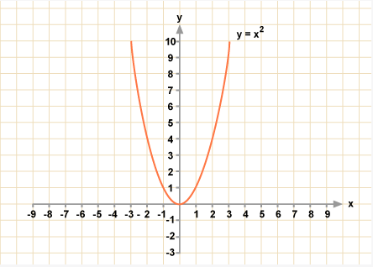

Here is the graph we get from the various outputs from our code

As our graph is very identical to the graph of y = $x^{2}$, we can come to the conclusion that the time complexity of our code is F(n) = O($n^{2}$)

Time complexity:

For loop in line 17, 29, 41, 54, the big O notation is O($n^{2}$)

If statements in line 45, 47, 58, 65, the big O notation is O(1)

If else statement in line 72 and 73, the big O notation is O(n)

The other variable declaration, scan and print statements etc. have big O notation of O(1)

Now,

The number of for loops = 4

The number of if statements = 4

The number of if-else statements = 1

So,

$n^{2}$ + $n^{2}$ + $n^{2}$ + $n^{2}$ +n +1+1+1+1

= 4 $n^{2}$ +n+4

Now,

4 $n^{2}$ +n+4 <= 4 $n^{2}$ + $n^{2}$ + $4n^{2}$

Or, 4 $n^{2}$ +n+4 <= 9 $n^{2}$

F(n)=O($n^{2}$)